

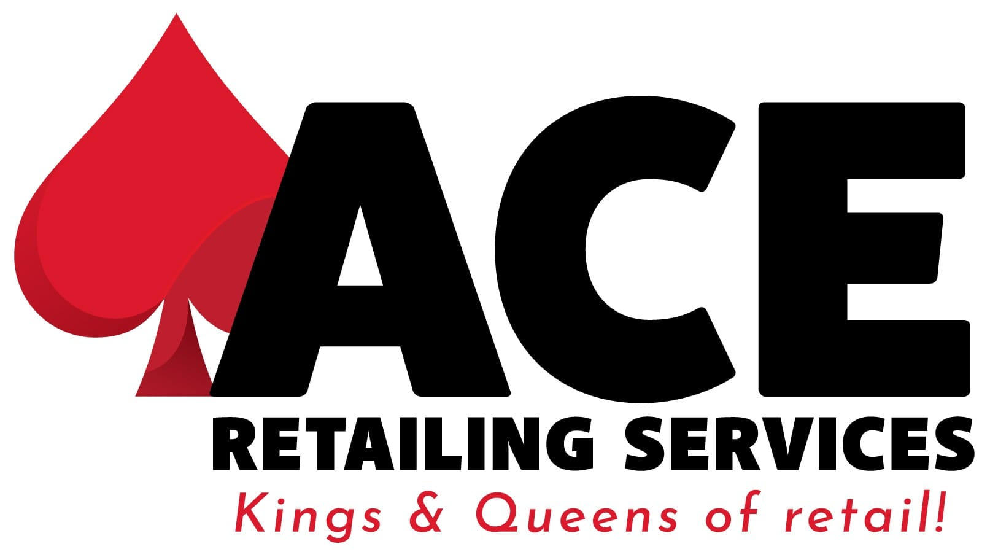

ORDER FORM

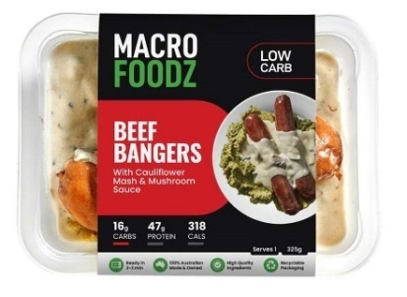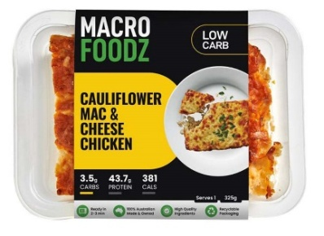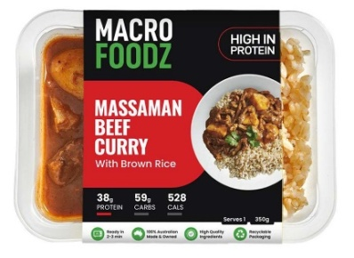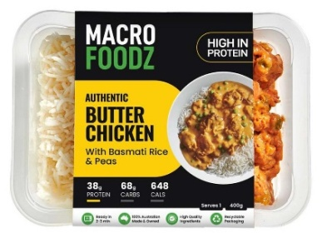



**30% GROSS MARGIN FOR STORES**

First Order For **FREE**  * **15 unit Minimum** Order(Mixed) * **Sale or Return** Available

|  |  |  |  |  |  |  |
| --- | --- | --- | --- | --- | --- | --- |
| **CODE** | **BARCODE** | **LOW CARB MEALS** | **Unit Price** | **RRP** | **Quantity** | **Shelf Life** |
| **KBL** | 794712488255 | HIGH PROTEIN BEEF LASAGNE RICOTTA CHEESE (325g) | $7.69 | $10.95 |  | 15 Days |
| **CCC** | 794712488378 | CAULIFLOWER CHICKEN AND CHEESE (325g) | $7.69 | $10.95 |  | 15 Days |
| **KBC** | 794712488118 | AUTHENTIC BUTTER CHICKEN/CAULIRICE/BUTTER  CHICKENSAUCE (325g) | $7.69 | $10.95 |  | 15 Days |
| **BCC** | 794712488156 | BEEF CON CARNE/CAULIRICE (350g) | $7.69 | $10.95 |  | 15 Days |
| **TCV** | 794712488521 | TERIYAKI CHICKEN AND VEG (275g) | $7.69 | $10.95 |  | 15 Days |
| **TCC** | 794712488316 | TANDOORI CHICKEN/CAULIFLOWERRICE/EVEREST  SAUCE (300g) | $7.69 | $10.95 |  | 15 Days |
| **GPP** | 794712488125 | GLUTEN FREE PERI PERI CHICKEN WITH BROCCOLI  RICE (325g) | $7.69 | $10.95 |  | 15 Days |

|  |  |  |  |  |  |  |
| --- | --- | --- | --- | --- | --- | --- |
| **CODE** | **BARCODE** | **HIGH PROTEIN MEALS** | **UnitPrice** | **RRP** | **Quantity** | **Shelf Life** |
| **BCB** | 794712488392 | BUTTER CHICKEN/BASMATIRICE/PEAS/BUTTER  CHICKEN SAUCE (375g) | $7.69 | $10.95 |  | 15 Days |
| **CCB** | 794712488965 | CHIPOTLE CHICKEN BURRITO BOWL/WHITE RICE  AND ROASTED VEGETABLES (400g) | $7.69 | $10.95 |  | 15 Days |
| **BSF** | 794712488996 | BEEF STROGANOFF WITH FETTUCCINE (350g) | $7.69 | $10.95 |  | 15 Days |
| **SB** | 794712488002 | SPAGHETTI BEEF BOLOGNESE (400g) | $7.69 | $10.95 |  | 15 Days |
| **PPB** | 794712488989 | PERI PERI CHICKEN/BROWNRICEANDROASTED  MIX VEG (400g) | $7.69 | $10.95 |  | 15 Days |
| **CBR** | 794712488170 | BEEF CON CARNE/BASMATI RICE (400g) | $7.69 | $10.95 |  | 15 Days |
| **CPC** | 794712488361 | PESTO CHICKEN/FETTUCCINE (400g) | $7.69 | $10.95 |  | 15 Days |

**How To Place Order**Options for placing order:  
1. Please contact your rep to place your order.   
2. Send your orders to macrofoodzaustralia@gmail.com  
3. Place your order on Macrofoodz retail online portal [ https://retail.macrofoodz.com.au ]

4. Order on Chargethrough Platform

# Customer Details

Name: Email: Phone: Store Accounts email: Chargethrough Supplier Number: Delivery Address: Suburb: Postcode: State:

**WHY MACROFOODZ MEALS?**

* **LOW CARB** -The first true low carb meals that’s been proven macrofoodz@sortedinvoicing.auto be nutritious and delicious.
* **MACROFOODZ is 100% Proud Australian Family owned**.
* **FRESH AUSTRALIAN VEGETABLES** - We only use fresh and authentic high quality Australian vegetables supporting Aussie farmers.
* **HIGH QUALITY INGREDIENTS** - We only use locally sourced and premium quality ingredients to create our meals from scratch.
* **RECYCLABLE PACKAGING** – All our packaging is 100% recyclable that means we can create a more sustainable and circular economy.

**CHARGETHROUGH TRADING NUMBER**

|  |  |  |  |  |
| --- | --- | --- | --- | --- |
| STATE | TRADING NUMBER | TRADING NAME | DELIVERY TYPE | BRANCH CODE |
| NSW | 1102961 | MACROFOODZ CT | CHARGETHROUGH | 050 |
| QLD | 1302961 | MACROFOODZ CT | CHARGETHROUGH | 017 |
| SA | 1502961 | MACROFOODZ CT | CHARGETHROUGH | 961 |
| VIC | 1202961 | MACROFOODZ CT | CHARGETHROUGH | 077 |
| WA | 1402961 | MACROFOODZ CT | CHARGETHROUGH | 994 |